CS 575

Project #3

Functional Decomposition

Xuming Wu

wuxum@oregonstate.edu

In this project, I used farmer as my own-choice quantity. The number of farmers affects both the amount the grain grows and the number of deer. Each farmer increases the growth of grain by 5.0 inches per month and eats 0.5 deer per month. Meanwhile, the number of farmers is affected by the number of deer since (# of deer / 5) farmers are needed to take care of deer.

Then, the output table and graph of the simulation are:

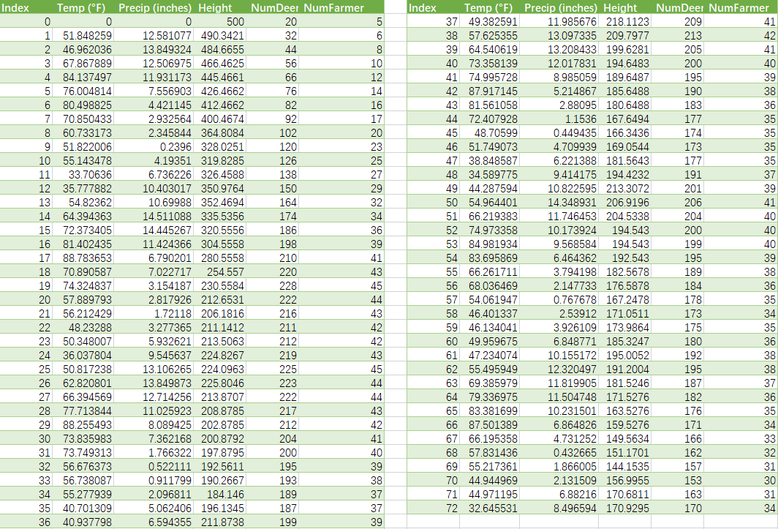

From the graph, we can observe at the beginning that the amount of grain decreases while the number of deer and farmer increase. It is because the amount of grain is sufficient for deer reproduction. Since the number of deer increases, more farmers are needed to take care of them. At this time, the growth (the growth affected by Temp and Precip plus the growth affected by farmers) cannot satisfy the deer’s need, so the Height decreases. At about the 20th month, the amount of grain, deer, and farmer reaches a balance point. Now, the consumption of grain matches its production. This shows that my own quantity is affecting the simulation correctly, otherwise, it would not reach this balance point. After this point, the impacts of Temp and Precip on Height, NumDeer, and NumFarmer turn to be obvious. Temp and Precip determine how good the grain grows and hence impact the number of both deer and farmers. Since Temp and Precip follow cosine and sine wave patterns, the curves of Height, NumDeer, and NumFarmer follow the patterns as well.